Human Rights and Social Justice Scholars Program 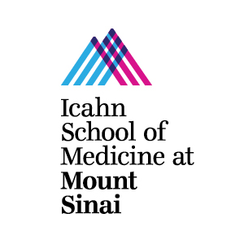
At the Icahn School of Medicine at Mount Sinai
Contact: hrsj@icahn.mssm.edu

What is the Human Rights and Social Justice Scholars Program (HRSJ)?

In 2011, Mount Sinai School of Medicine’s chapter of Physicians for Human Rights partnered with the Department of Medical Education, Center for Multicultural Affairs (CMCA), and the Global Health Center to launch the Human Rights & Social Justice Scholars Program (HRSJ) at the Icahn School of Medicine at Mount Sinai. HRSJ is a unique multidisciplinary program that offers a group of first year medical students a comprehensive curriculum in health equity, human rights, and social justice through mentorship, research, advocacy, and coursework. We aim to empower medical students with the knowledge, skill set, and conviction to become patient advocates in the broadest sense. We host events throughout the school year on a number of topics and run the Health, Human Rights and Advocacy elective course (HHRA) for medical students.

What is the Service Learning Experience Program?

HRSJ scholars will have the opportunity to explore a number of community identified issues in East Harlem and the wider New York City area through coursework and selected service learning experiences within, but not limited to, the following themes:

- Emergency Preparedness
- Pediatric Mental health
- Incarceration of Women
- Homelessness
- Community Health/Health Policy
- Dismantling Racism
- Harm Reduction
- LGBTQ Health
- Reproductive Justice
- Immigration Health

Students will have a series of meaningful experiences that help inform their understanding of a theme through a health equity and social justice lens. Experiences within a particular theme, for example incarceration, might range from attending a health policy conference on correctional health care to shadowing a physician who works on Rikers Island to learning about an East Harlem-based program that offers services this population. HRSJ scholars who identify a meaningful volunteering experience that is beneficial to a community partner organization are encouraged to pursue it during the academic year. Scholars who identify a concrete project or a research question they are interested in pursuing while completing the service learning experience program will work with a faculty advisor from Mount Sinai to guide that experience.

